1. **Goal**
   1. The high level goal for this sprint is to set up the core features for the mobile app, including a personalized profile page, a home page that includes the user’s friends’ posts, and the ability to follow/unfollow others. To be able to properly test these features, we will also have to generate seed data and gain access to the user’s native functionalities, like the camera and location.
2. **Task Listing**
   1. As a user, I would like to see my profile page so that I can view my past posts and interactions [13]
      1. Create a frontend profile page containing a user header, social information (followers, following, etc), post squares, and achievements (6 hours)
      2. Create a profile followers and following screen to show users’ friends lists, as well as suggested users that they can follow (6 hours)
      3. Create a post screen to be able to click on a post and take it to the screen (2 hours)
      4. Create backend endpoints to get user profile information, including bio, # of followers / following, people followed and following, and number of foods eaten (# of posts). (5 hours)
      5. Create a backend endpoint to retrieve a post from the database. (3 hours)
      6. Create backend endpoints to edit a user’s profile information. (2 hours)
   2. As a user, I would like to be able to make a post to show my friends what I am eating [8]
      1. Create a frontend post screen that shows its photo, caption, user who posted it, rating, restaurant, and dish name (4 hours)
         1. Also include likes, comments, and to-eat adds
      2. Create backend endpoints to create, delete, and edit user’s posts. (3 hours)
      3. Create backend endpoints to obtain the number of likes on a post, like a post, obtain the number of comments on a post, obtain the comments of a post, and comment on a post. (1 hour)
      4. Create backend endpoints to add a post to your “to-eats” list and to remove a post from your “to-eats” list. (2 hours)
   3. As a user, I would like to follow and unfollow accounts so that I can make a network of friends [8]
      1. Create a follow endpoint that adds the users’ ids to a relational table. (3 hours)
      2. Create an unfollow endpoint that removes the users’ ids from the relational table. (2 hours)
      3. Create a frontend for clicking on a user’s profile and being able to follow/unfollow them. (1 hour)
3. **Team Roles**
   1. Luca Schram: Developer
   2. Keaton Shawhan: Product Owner
   3. Nico Vitagliano: Scrum Master
   4. Zoe Feller: Developer
   5. Jake Gurien: Developer
4. **Task Assignment**
   1. Luca Schram
      1. Add seed data to the database for the sake of API and feature testing [Infrastructure]
         1. Add a SQL file that injects fake data into db at schema creation time to enable endpoint testing.
         2. Edit dockerfile to only inject seed data when the database is initially created, not every time it is built.
      2. Add Jest tests for all endpoints to ensure endpoint stability [Infrastructure]
         1. Create a file to build a secondary testing database copy to not edit the production database.
         2. Set up mock endpoint calls and edit production endpoints if necessary.
   2. Keaton Shawhan
      1. As a user, I would like to follow and unfollow accounts so that I can make a network of friends.
         1. Create a follow endpoint that adds the users’ ids to a relational table.
         2. Create an unfollow endpoint that removes the users’ ids from the relational table.
         3. Create a frontend for clicking on a user’s profile and being able to follow/unfollow them.
      2. As a user, I would like to be able to make a post to show my friends what I am eating [8]
         1. Create backend endpoints to create, delete, and edit user’s posts.
         2. Create backend endpoints to obtain the number of likes on a post, like a post, obtain the number of comments on a post, obtain the comments of a post, and comment on a post.
         3. Create backend endpoints to add a post to your “to-eats” list and to remove a post from your “to-eats” list.
   3. Nico Vitagliano
      1. As a user, I would like to be able to make a post to show my friends what I am eating.
         1. Create a frontend post screen that shows its photo, caption, user who posted it, rating, restaurant, and dish name
            1. Also include likes, comments, and to-eat adds
         2. Create backend endpoints to obtain the number of likes on a post, like a post, obtain the number of comments on a post, obtain the comments of a post, and comment on a post.
   4. Jake Gurien
      1. As a user, I would like to see my profile page so that I can view my past posts and interactions
         1. Create a frontend profile page containing a user header, social information (followers, following, etc), post squares, and achievements
         2. Create a profile followers and following screen to show users’ friends lists, as well as suggested users that they can follow
         3. Create a post screen to be able to click on a post and take it to the screen
         4. Create a backend endpoint to retrieve a post from the database
         5. Create backend endpoints to edit a user’s profile information
   5. Zoe Feller
      1. As a user, I would like to be able to make a post to show my friends what I am eating.
         1. Create a frontend post screen that shows its photo, caption, user who posted it, rating, restaurant, and dish name
            1. Also include likes, comments, and to-eat adds
      2. As a user, I would like to see my profile page so that I can view my past posts and interactions
         1. Create a post screen to be able to click on a post and take it to the screen
         2. Create backend endpoints to get user profile information, including bio, # of followers / following, people followed and following, and number of foods eaten (# of posts)
5. **Burnup Chart**

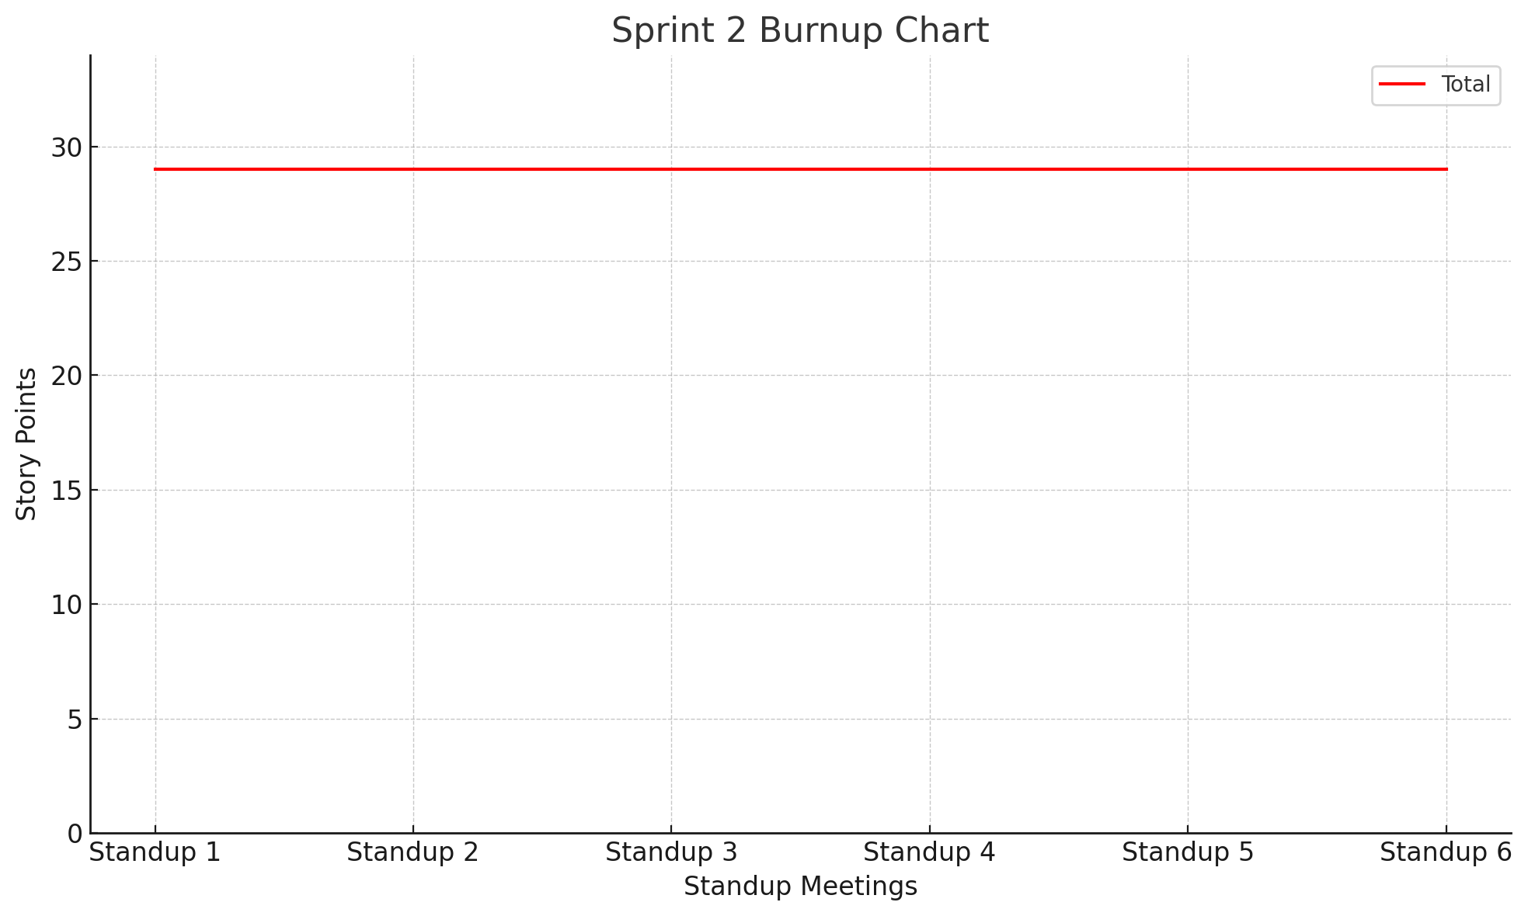

1. **Scrum Times**
   1. Week 4 (Sprint began after TA Meeting)
      1. Wednesday 10/23/24 - 11:00 A.M.
      2. Friday 10/25/24 - 11:00 A.M.
   2. Week 5
      1. Monday 10/28/24 - 11:00 A.M. - **TA Meeting**
      2. Wednesday 10/30/24 - 11:00 A.M.
      3. Friday 11/1/24 - 11:30 A.M.
   3. Week 6 (Half Sprint)
      1. Monday 11/4/24 - 11:00 A.M. - **TA Meeting**
      2. Wednesday 11/6/24 - 1:30 P.M. - **End of Sprint 2**